MLOPS Assignment2

Name: Priya N Singh
USN: 4GW23CI042

1. Which run had the lowest latency,and why might that be?

run_batch4 had the lowest latency (0.058s), followed by run_batch8 (0.059s) and run_batch1 (0.207s). With a larger batch size, the model processes multiple sentences in one forward pass, reducing the number of calls and the overhead per call. run_batch1 processes sentences individually, so it takes more time. The first run may also include a one-time model warm-up cost.

2. Did accuracy change between runs? Why or why not?

No, accuracy remained the same at 1.0 (100%) in all three runs. Every run used the same pre-trained model with the same weights and the same 10 sentences. Batch size only changes how many sentences are processed at a time, which affects processing speed but not the model's predictions.

3. Name two benefits of using MLflow here instead of printing results in the terminal.

Two benefits of using MLflow:

1. Reproducibility and record-keeping: MLflow saves the parameters, metrics, and artifacts (predictions.csv) of every run. Unlike terminal output, the results remain saved even after closing the window.

2. Easy comparison: MLflow allows us to compare multiple runs side by side using tables and charts in the UI, making it easier to understand the differences between runs.

Screenshot of the MLflow run stable:

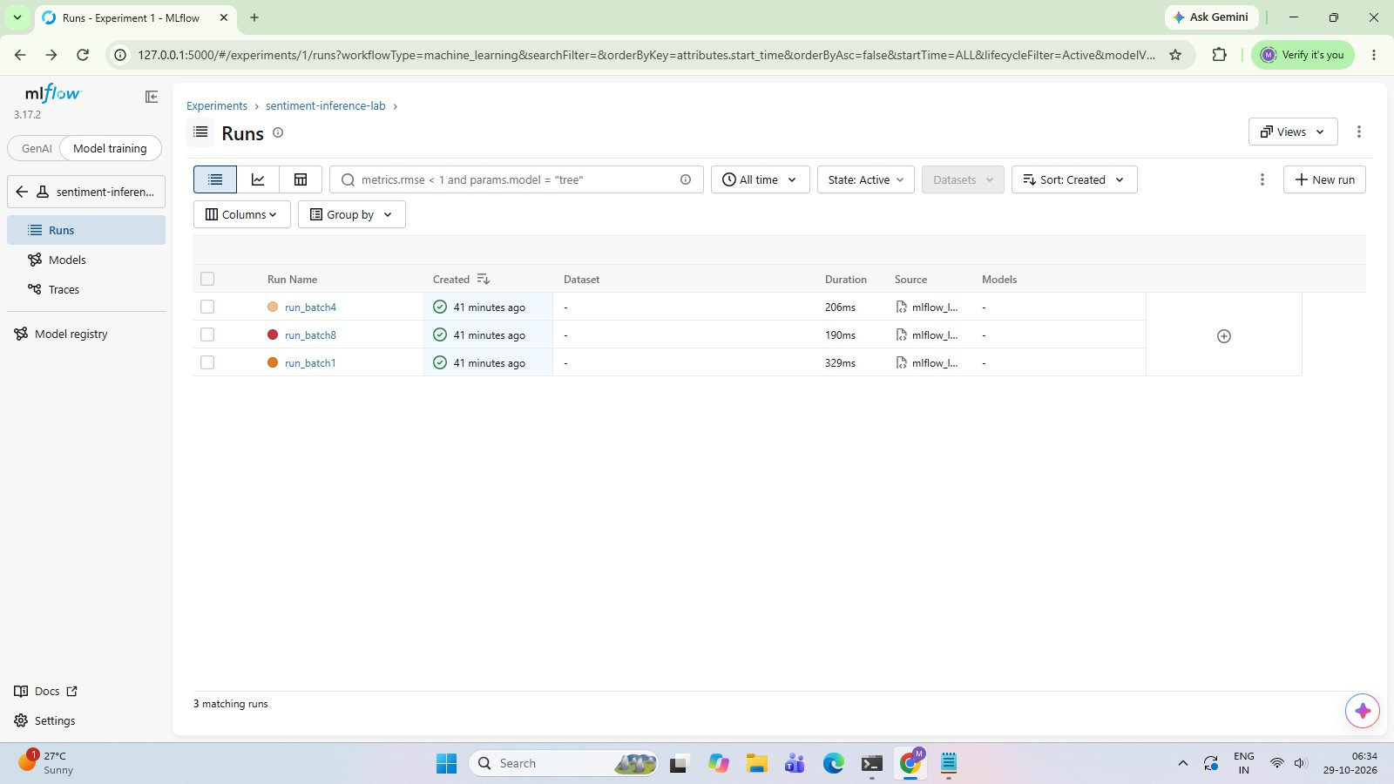

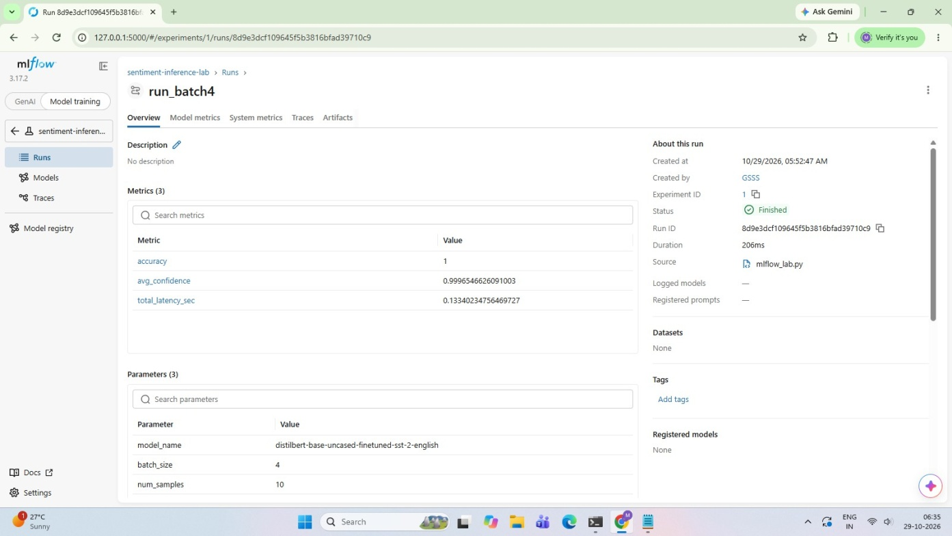

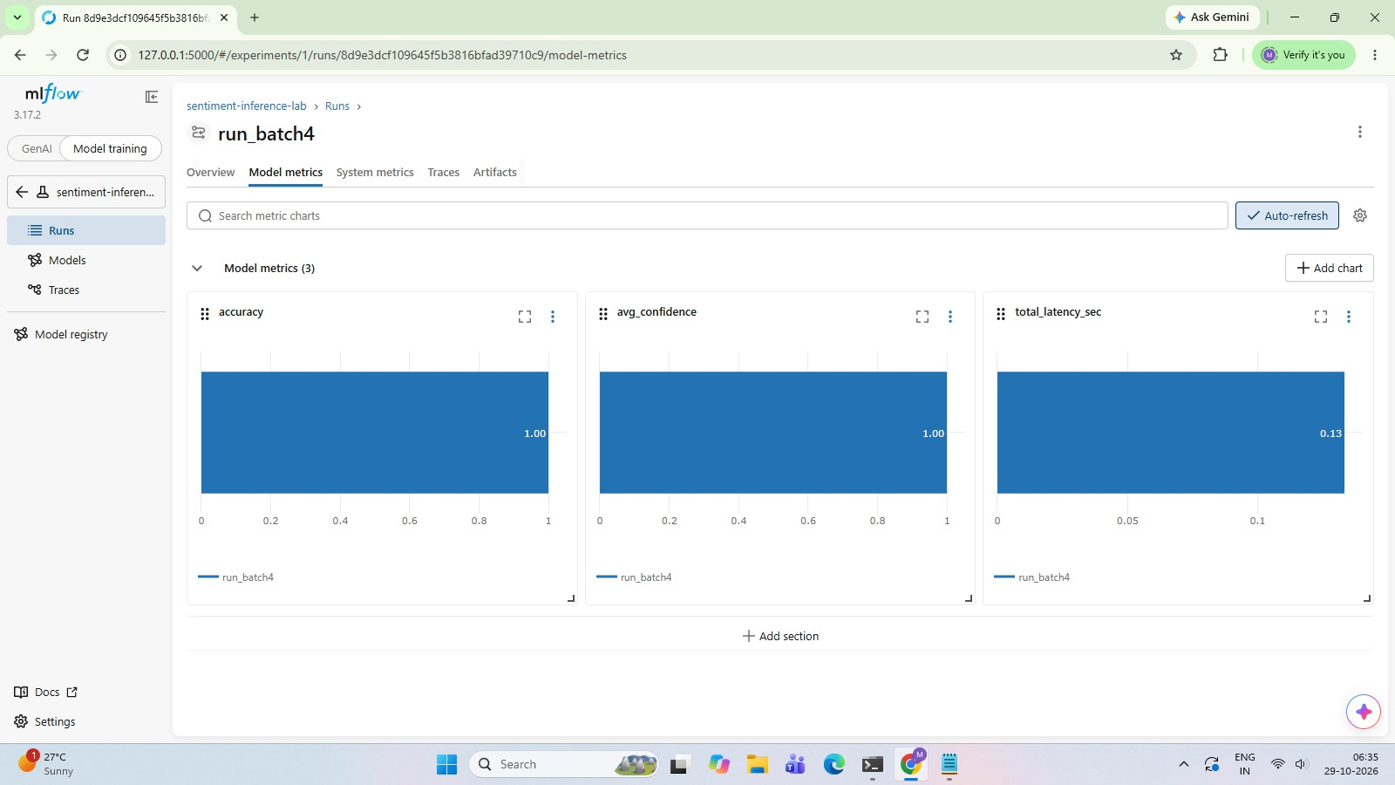

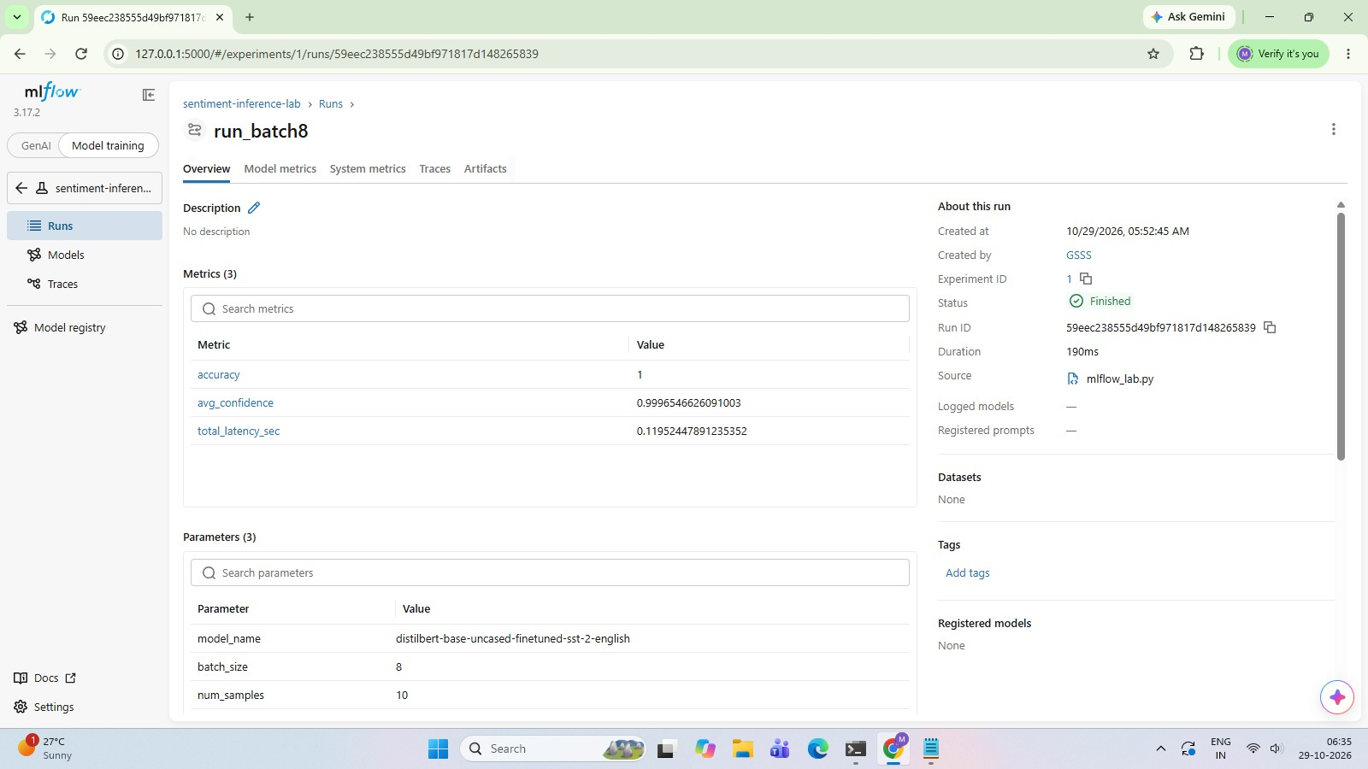

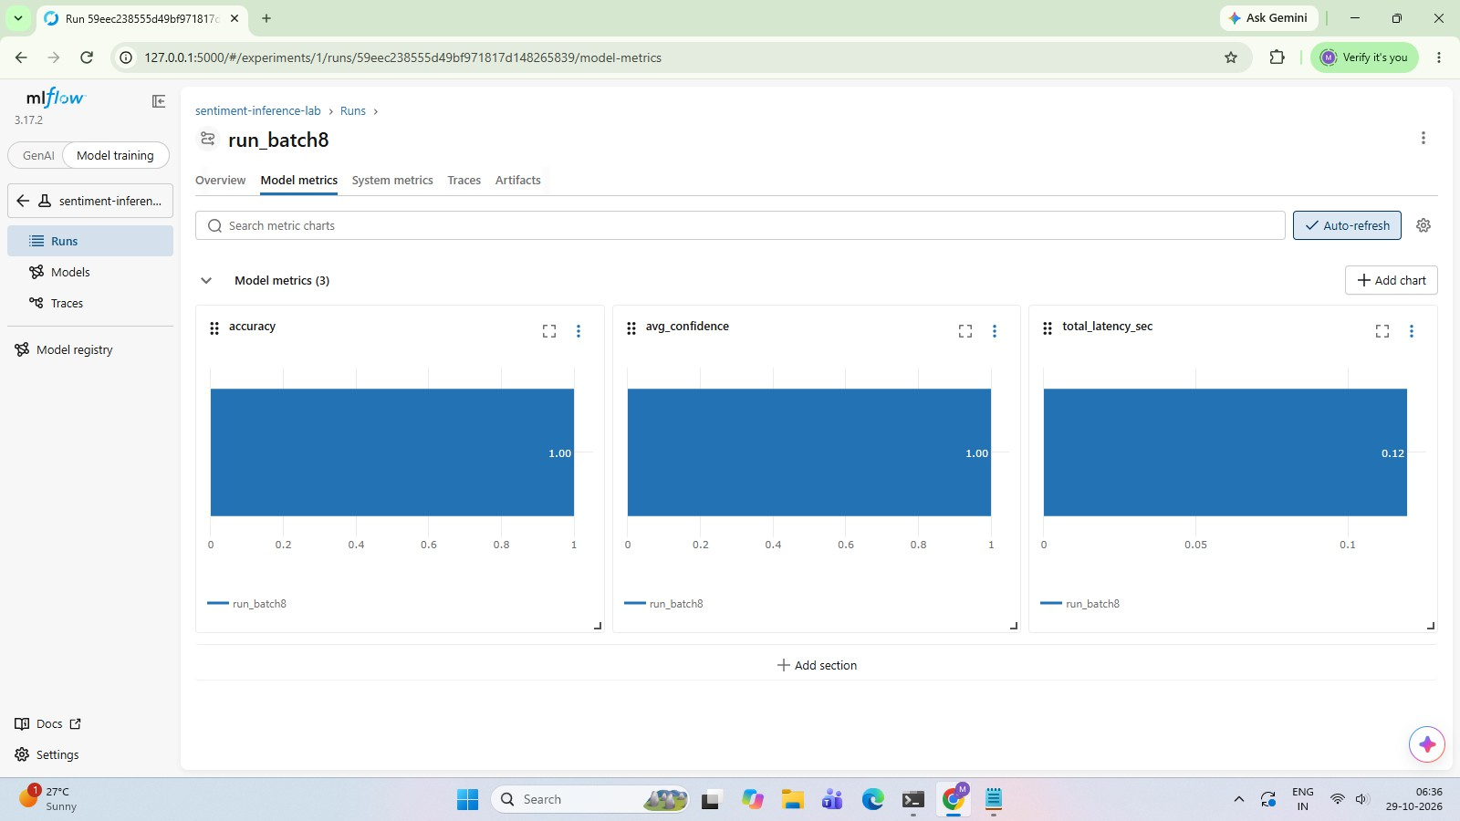

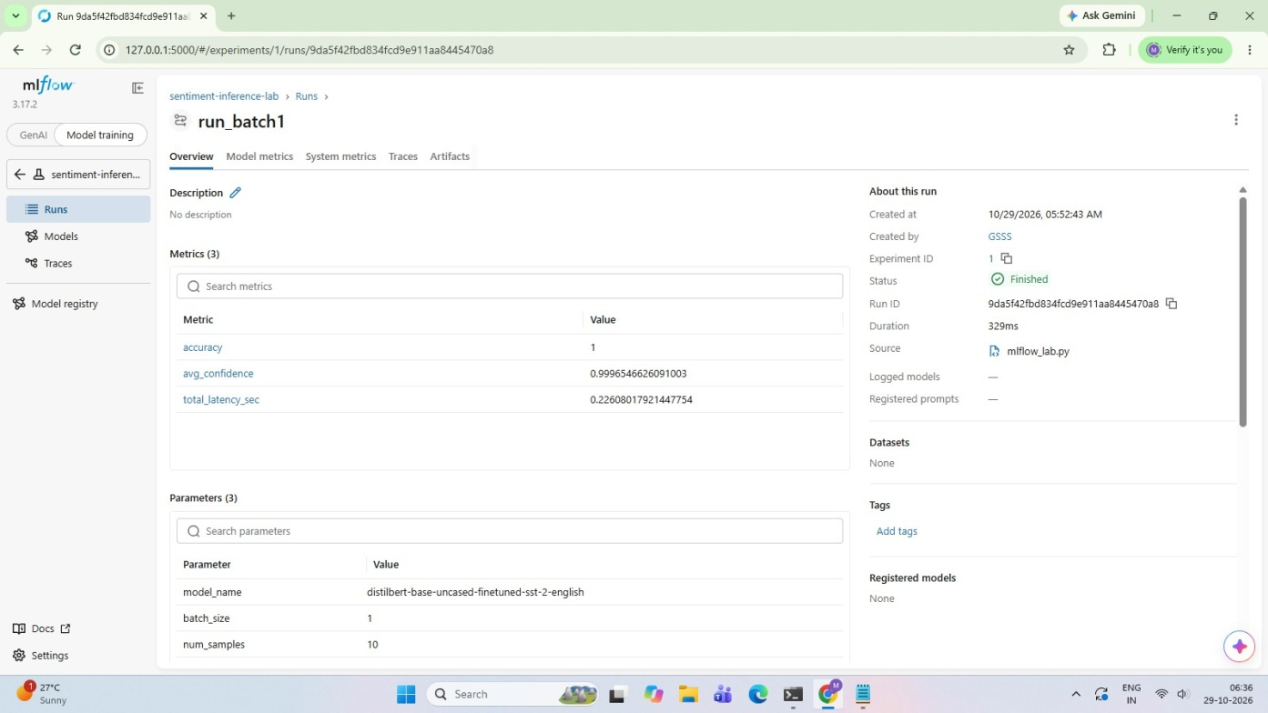

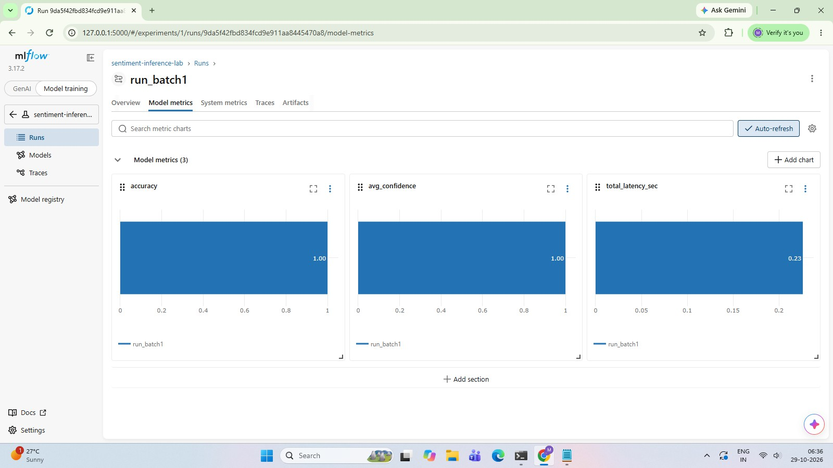

Screenshot of the Compare view:

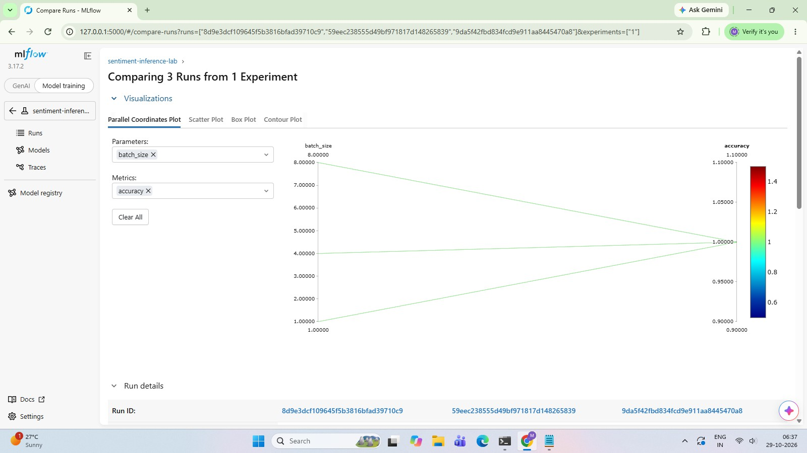

mlflow_lab.pyfile:

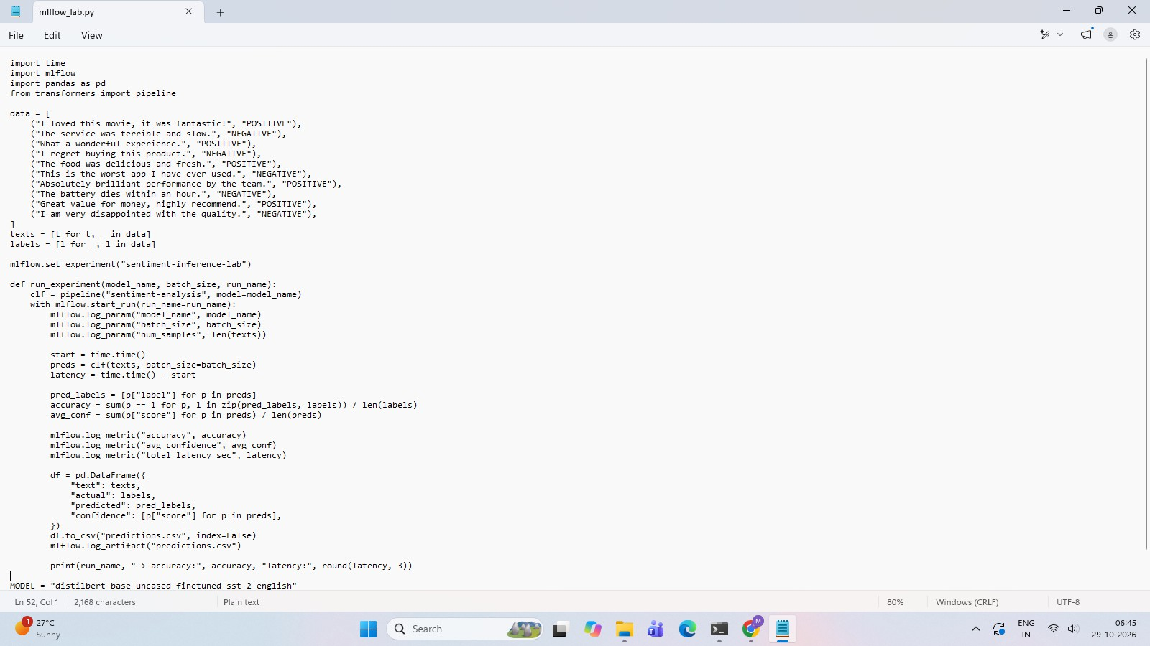

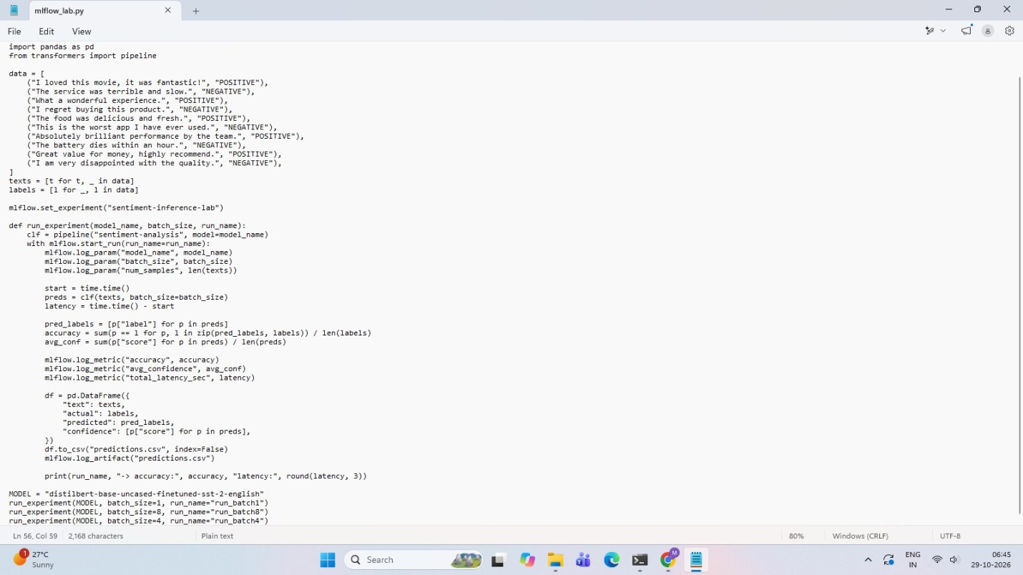

Execution:



